Experiment 2: Setting Up a Zoho Creator Account and Exploring the Platform Architecture and Interface

Aim:
To create a Zoho Creator account and explore the platform architecture, features, and
user interface for developing low-code applications.

Theory:
Zoho Creator is a cloud-based low-code application development platform that enables users to build custom business applications with minimal coding. It provides a visual development environment where applications can be designed using drag-and-drop components, forms, workflows, reports, and dashboards.

The platform architecture consists of the following components:
- Applications: Containers that hold all forms, reports, workflows, pages, and settings.
- Forms: Used to collect and store user data.
- Reports: Display and manage stored data in various formats such as lists, tables, and calendars.
- Pages: Custom interfaces that combine multiple components into a single view.
- Workflows: Automate tasks using event-based actions and business logic.
- Deluge Script: Zoho Creator's scripting language used to implement advanced functionality and automation.
- Users and Permissions: Control access to applications and define user roles.

The Zoho Creator interface includes the Home Dashboard, Application Builder, Form Designer, Report Builder, Workflow Builder, Navigation Panel, and Settings menu, allowing users to efficiently design, test, and deploy applications.

Procedure:
- Open a web browser and navigate to the Zoho Creator website.
- Create a Zoho account or sign in using existing credentials.
- Access the Zoho Creator dashboard.
- Create a new application using either a blank application or a pre-built template.
- Explore the Application Builder interface.
- Examine the Form Designer and add sample fields such as text, number, date, and email.
- Explore the Report Builder to view the generated records.
- Navigate through the Workflow section to understand automation features.
- Explore Pages, Settings, User Management, and Application Permissions.
- Observe the overall platform architecture and note the functions of each component.

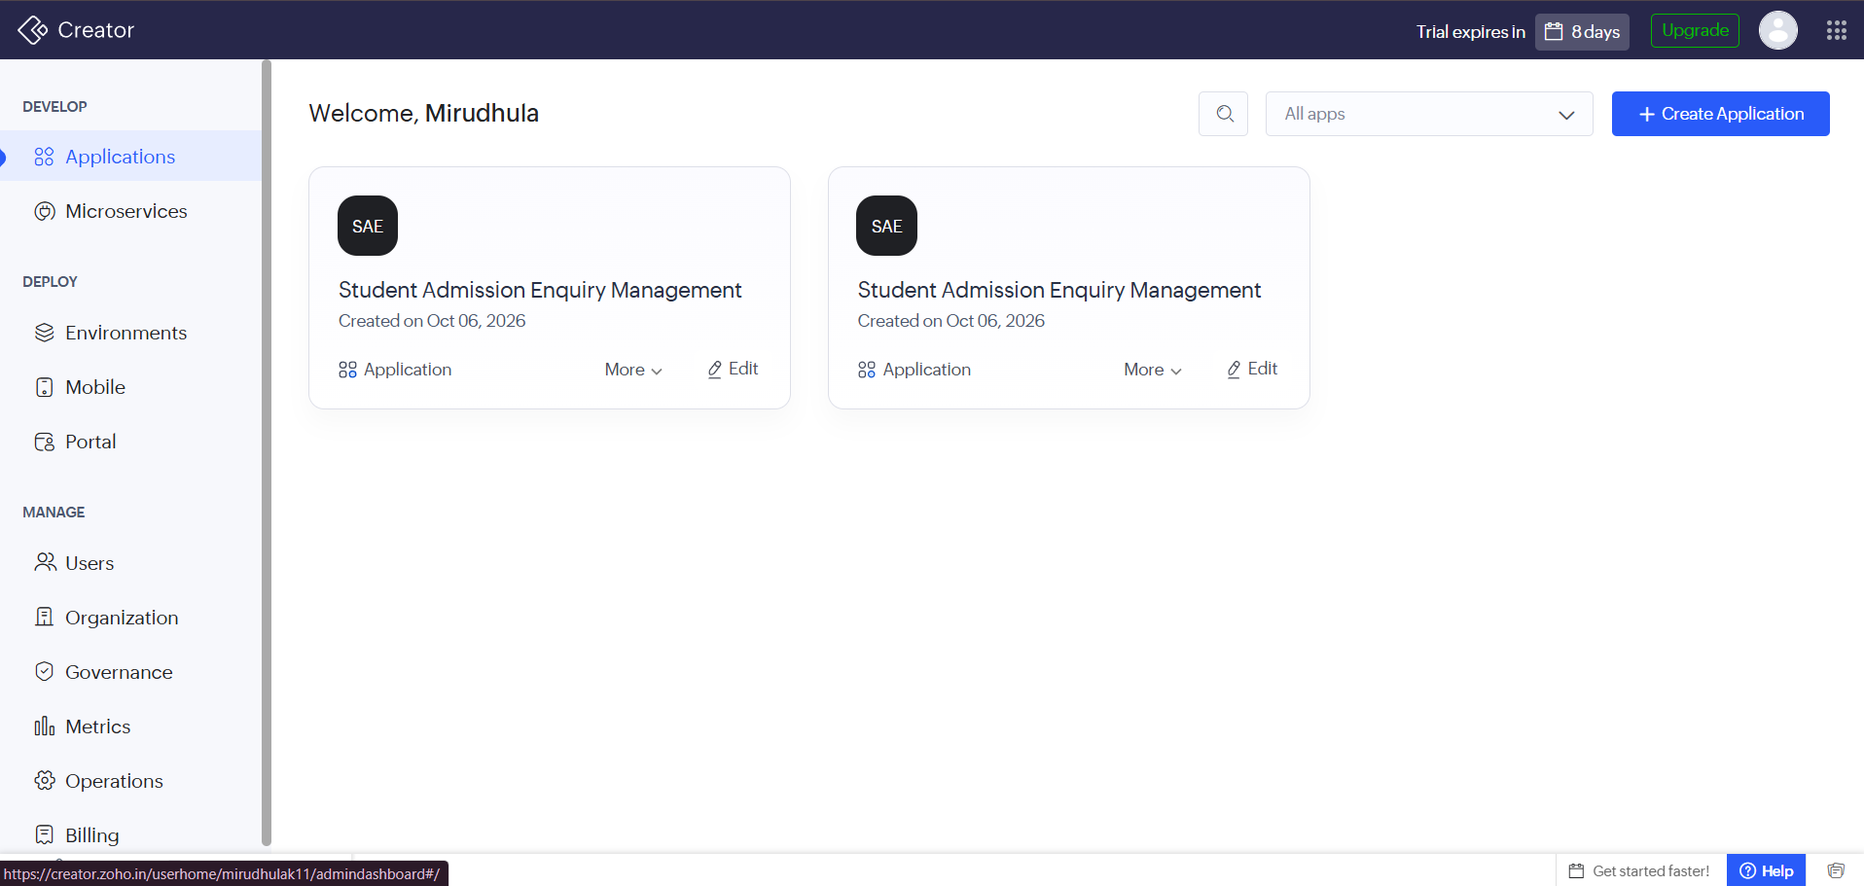

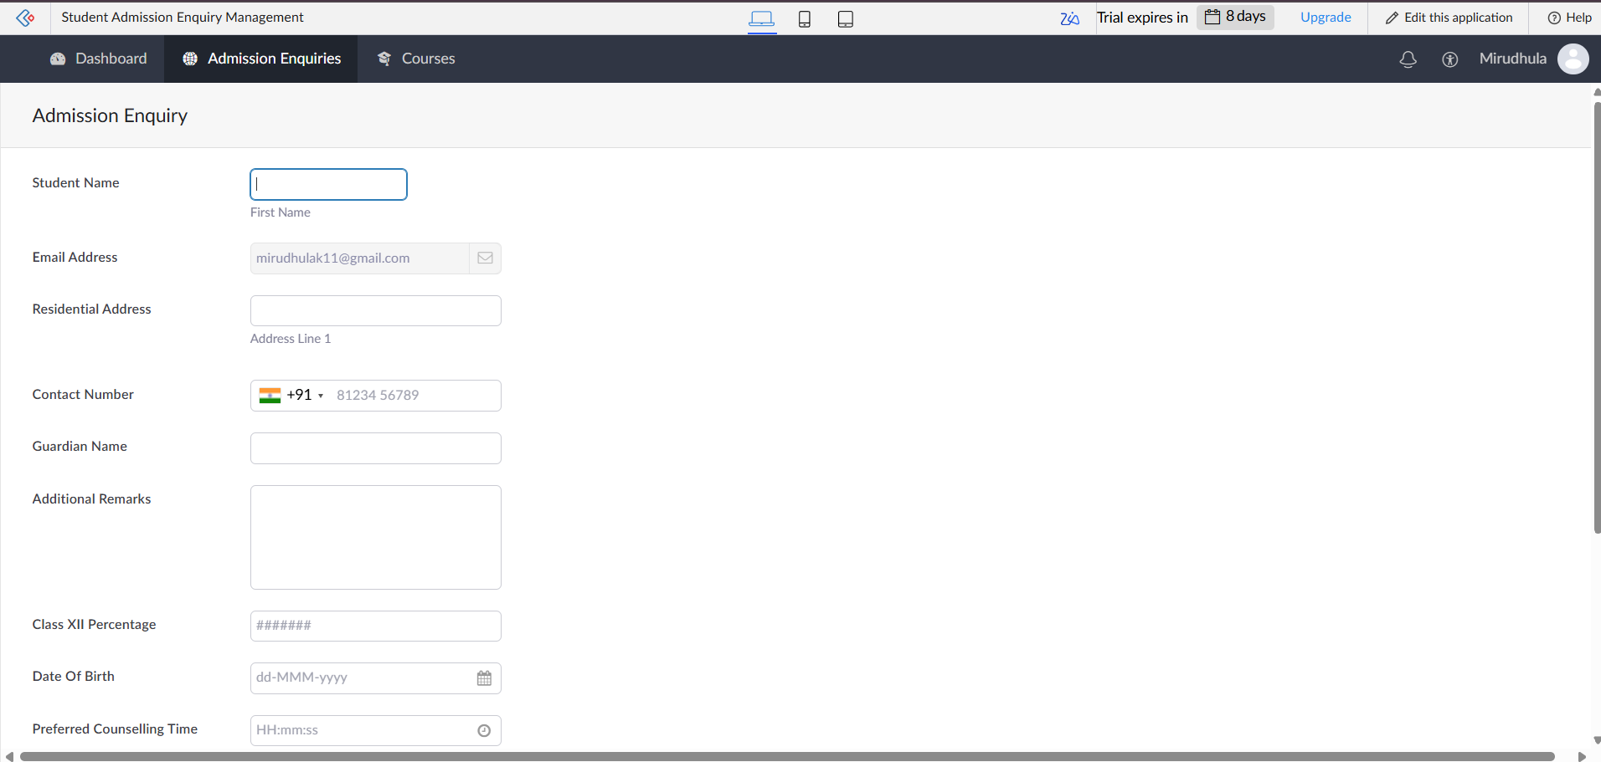

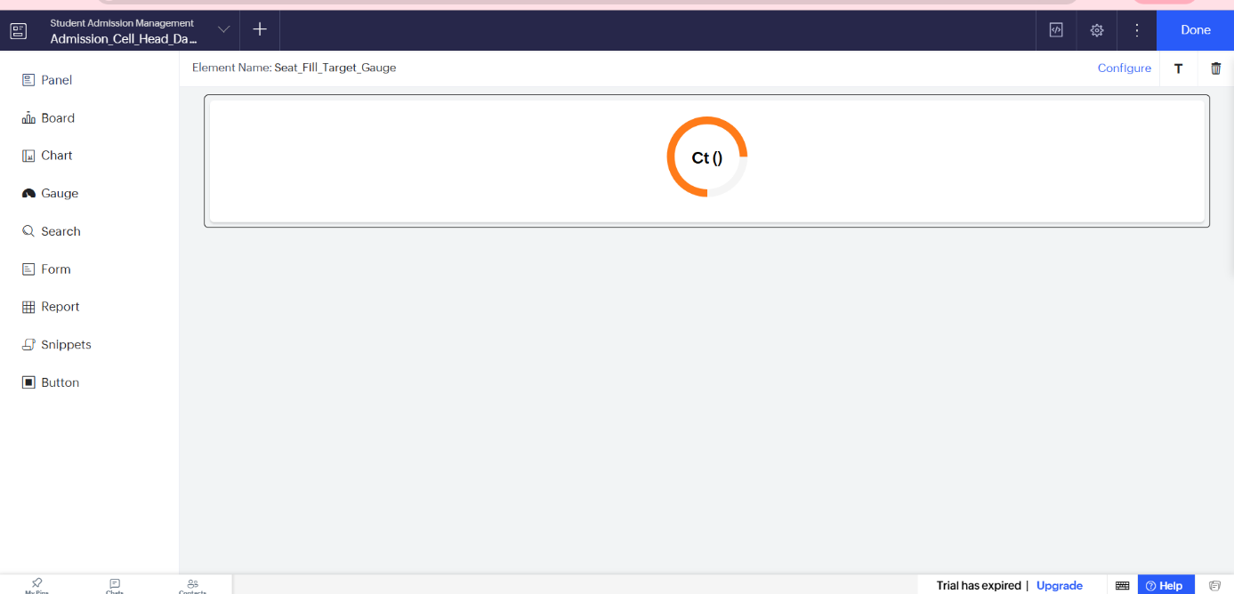

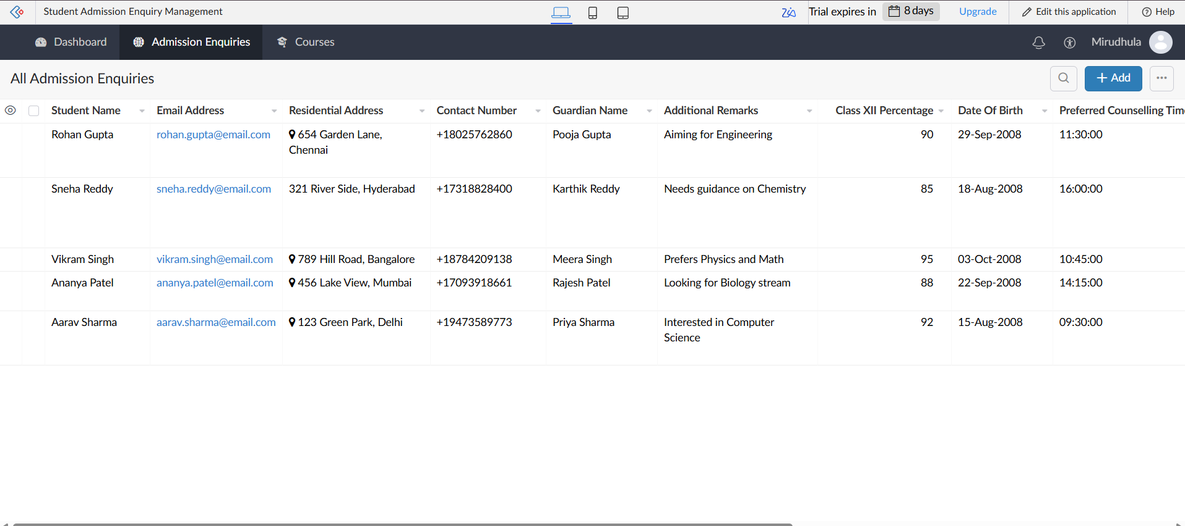

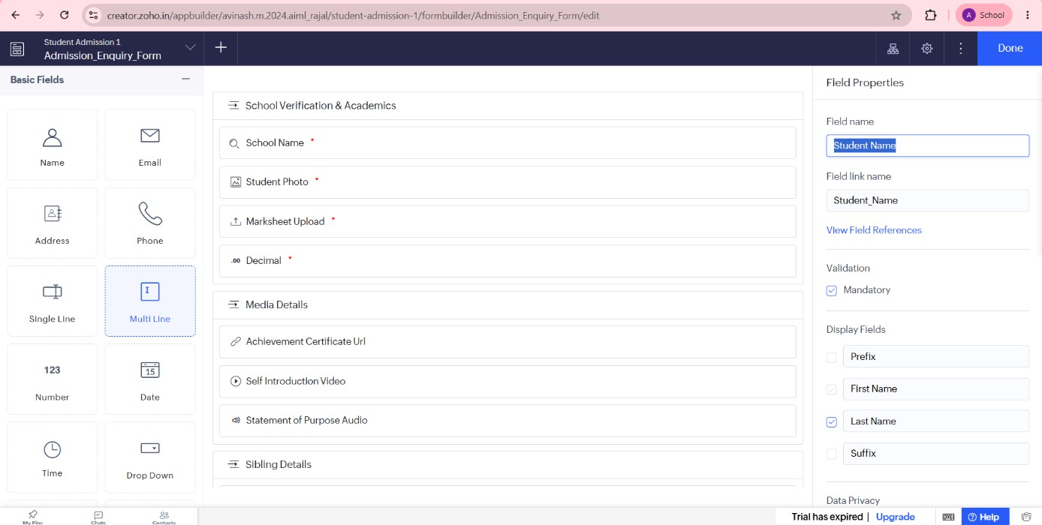

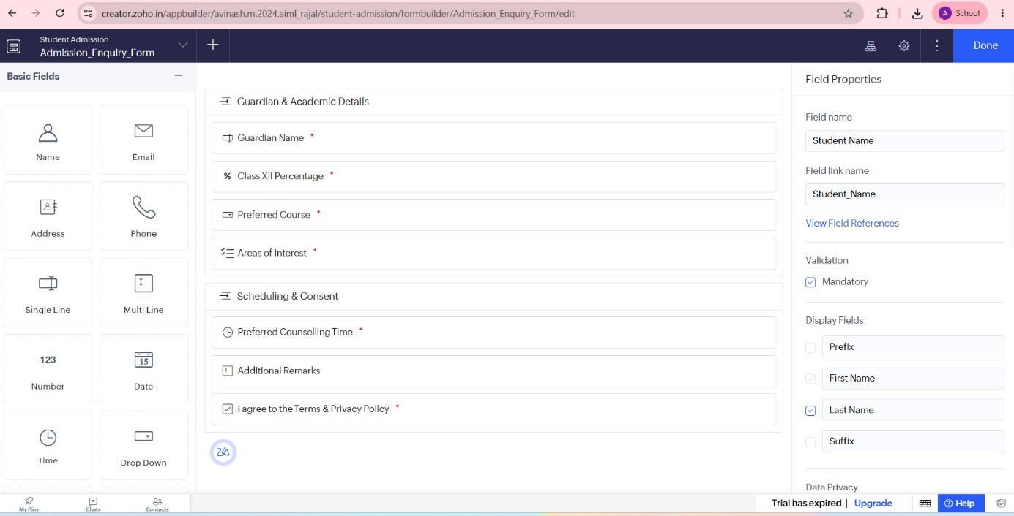

Result:
A Zoho Creator account was successfully created, and the platform architecture and user interface were explored. The experiment demonstrated that Zoho Creator provides an intuitive low-code environment with tools such as forms, reports, workflows, pages, and dashboards, enabling rapid application development with minimal programming effort.

